**GREENMOUNT**

**PRIMARY SCHOOL**

**School Community Plan**

**2018**

**—**

**2020**

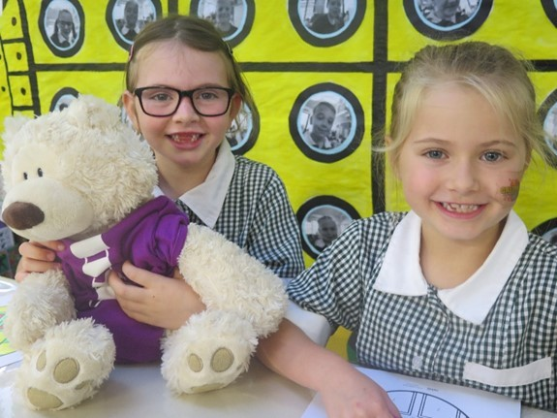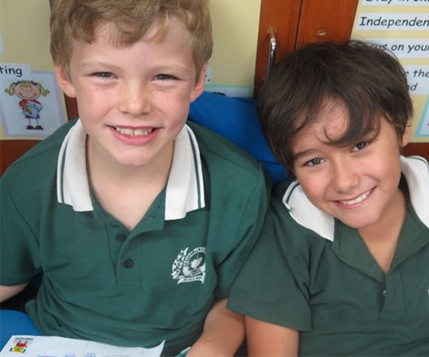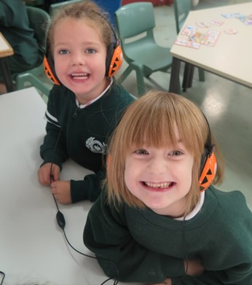

**Our Vision**

*At Greenmount Primary School we*

*strive to empower our students to*

*achieve their full potential.*

*We provide an inclusive, safe and*

*supportive learning environment and*

*engage students in quality learning*

*and teaching programs which equip*

*them with essential skills to be*

*lifelong learners.*

The first students of Greenmount Primary School enrolled

in July 1913 when the school was located in a small

cottage on Innamincka Road. Since 1964, the school has

operated from its current location and maintains strong

historical links to the Blackboy Hill Commemorative site.

The school continues to be well regarded in the local

community.

Greenmount Primary School has an excellent reputation

for its inclusive approach to education and its focus on all

aspects of our students

’

development. The staff, parents

and carers work collaboratively in a mutually respectful

and supportive environment. There is a genuine sense of

community which is valued by all.

Catering for a stable population of approximately 380

students from Kindergarten to Year 6, the dedicated and

professional staff deliver comprehensive educational

programs which encompass the development of key

social skills and engagement in learning.

Our School Community Plan outlines the school

’

s

strategic direction for 2018

-

2020

with details of priorities,

key focus areas, targets and strategies. It has been

developed in collaboration with the School Board and

Greenmount Primary School staff. As a working

document, it will be revisited regularly to ensure that we

are delivering quality teaching and learning programs and

meeting our set targets.

**Welcome to**

**Greenmount Primary School**

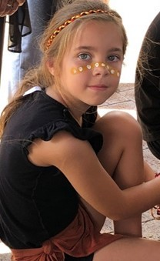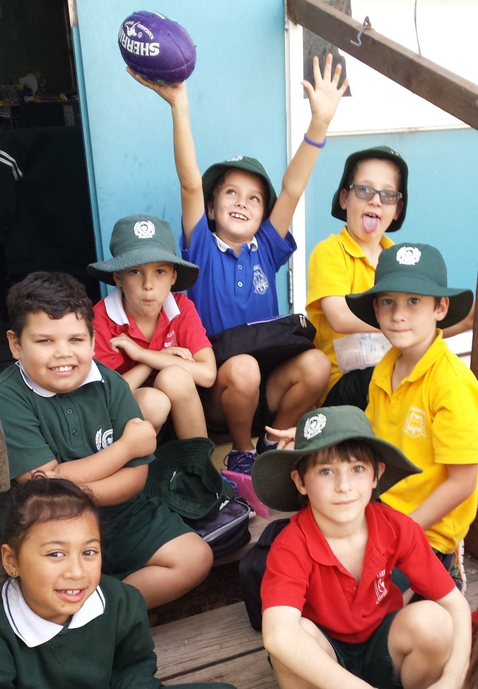

Our Beliefs

Our Values

Learning side by

side

We believe that students learn best when:

◻

They have a caring and safe environment

where their efforts and contributions are

valued and they feel supported

◻

They are set high expectations, appropriate

goals and are provided with regular

ongoing, informative feedback

◻

Their individual learning, social, physical,

and emotional needs are met

◻

Learning is integrated, purposeful and

connected to real life situations

◻

Students, home and school have a

commonly understood purpose and work

together

***Learning***

We are engaged in the learning process and

motivated to improve

***Respect***

We value each person

’

s differences, caring for

ourselves and others

***Resilience***

We can regulate our emotions, coping with

challenging situations and solving problems

***Responsibility***

We are accountable for our actions and able to

make positive choices

***Collaboration***

We work together, supporting each other

to learn and share our thinking and ideas

***Excellence***

We do our best in all that we do. We set

ourselves goals and work hard to achieve them

***Relationships***

We interact with everyone in a mutually

respectful and positive manner



Our Motto

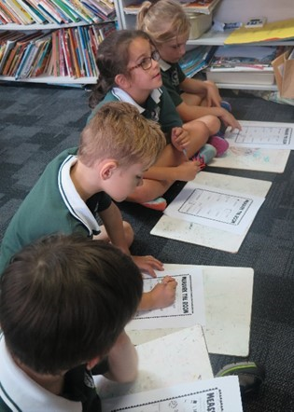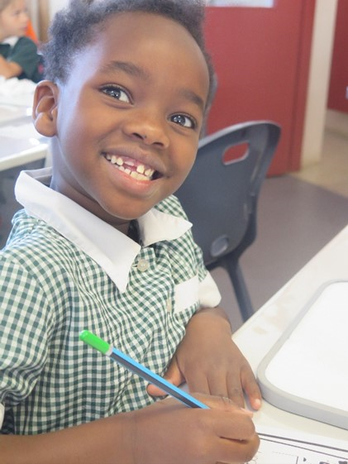

**SAFE and HAPPY STUDENTS**

Greenmount Primary School provides a learning environment in which students feel safe and

supported. Our positive and proactive approach develops resilient, socially and culturally aware and

responsible young people. We teach the skills and language needed to create a school community

where wellbeing is a focus.

***Targets:***

•

*BMIS data continues to reflect positive*

*student behaviours throughout the school*

•

*Student feedback reflects positive*

*dispositions and attitudes towards school*

*and school activities*

•

*The high percentage of students feeling safe*

*and happy at school is maintained*

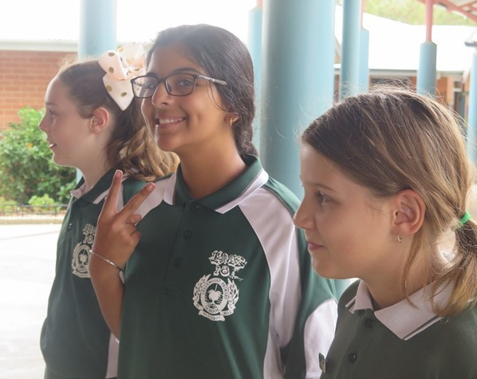

**INTENTIONS**

**SUCCESS CRITERIA**

***Students are provided with***

***the skills and language to***

***be successful in their***

***interactions with others***

•

The whole school behaviour focus is introduced at assemblies and

explicitly taught and modelled in all classrooms

•

The shared metalanguage of relationships, responsibility and

respect are used by the whole school community

•

Expectations of student behaviour are clarified, reinforced and

embedded in the school

***Positive behaviours are evident***

***and create a safe environment***

***conducive to learning***

•

The continuing implementation of the school

’

s

*Supporting Positive*

*Behaviour*

Policy develops consistency in metalanguage and

processes involved

•

Individual Behaviour Support Plans are implemented to provide

personal adjustments based on students

’

needs

•

CMS strategies are used to establish and maintain safe and

accountable learning environments

•

Additional teachers are trained to facilitate teacher conferencing

and feedback

***Students have a positive mindset***

***for learning***

•

Learning dispositions are taught and reinforced in all classrooms

•

Students are understanding of how a positive mindset impacts on

their learning

•

Students are taught, and understand, how the process of learning

helps them achieve their goals

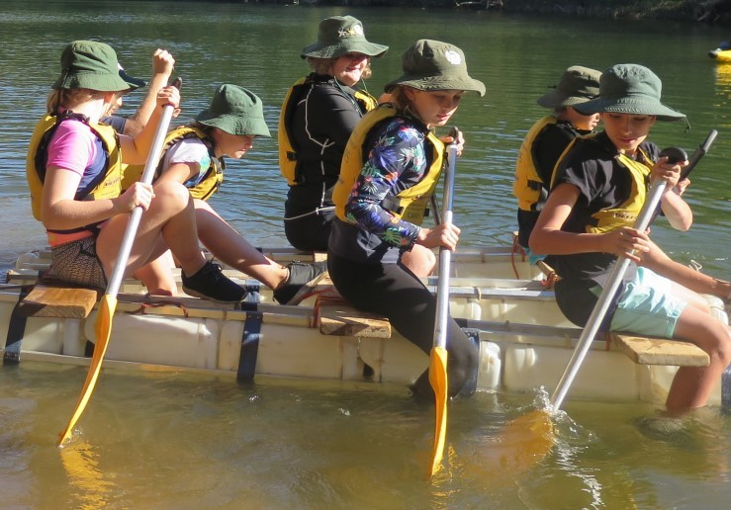

**ENGAGED and CHALLENGED**

At Greenmount Primary School students and staff have opportunities to develop their strengths

through challenge. Teachers use a comprehensive range of strategies to promote engagement with

learning and deliver programs that enrich student learning.

***Targets:***

•

*Classroom observations and student feedback*

*indicate that students are engaged in learning*

•

*Teacher survey reflects confidence in delivery and*

*implementation of STEM program*

•

*Individual Education Plans and Special Educational*

*Needs (SEN) reporting inform parents of individual*

*student progress and achievement*

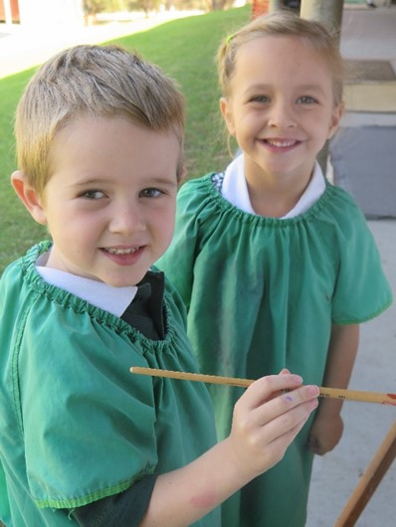

**INTENTIONS**

**SUCCESS CRITERIA**

***Students are explicitly taught***

***problem solving and higher order***

***thinking skills***

•

Teachers provide authentic tasks in learning where higher order

thinking skills are used

•

Collaborative tasks and integration of IT support problem solving

and creativity

•

Professional Learning is accessed by teachers, including

Questioning Techniques, Bloom

’

s Taxonomy and Higher Order

thinking skills

***Science, Technology, Engineering***

***and Mathematics (STEM) is***

***delivered in all classrooms***

•

Technologies curriculum is implemented and teachers confidently

report on student achievement

•

STEM program facilitates collaboration, creativity, problem solving

and higher order thinking

***Individual student needs are met***

***through differentiated programs***

***of work***

•

L

earning is targeted at varying levels, providing all students with

an opportunity to progress

•

Teachers develop a repertoire of strategies to cater for students

’

varying abilities and learning styles

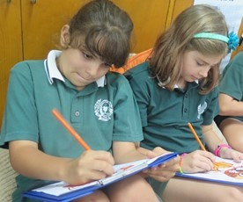

**LEARNERS**

**MATHEMATICS**

Greenmount Primary ensures students develop an appreciation of Mathematics across all

learning areas. Students approach Mathematics with confidence whilst building their skill base and

applying knowledge to problem solving tasks.

***Targets:***

•

*The Year 3 and 5 average to be equal to or*

*higher than*

Like Schools

*average in*

*NAPLAN Numeracy testing*

•

*Increase the percentage of students in*

*higher bands when compared to*

Like

Schools

**INTENTIONS**

**SUCCESS CRITERIA**

***Whole school data is used to set***

***targets for improvement and plan***

***effectively at school, class and***

***individual level***

•

Data is used to guide planning for students identified at risk and in

higher bands

•

Improvement targets clearly articulate expected achievement for

cohorts

•

Common assessment tasks and moderation inform the teaching

and learning program

***Opportunities are provided to***

***challenge and extend students***

***’***

***learning***

•

A bank of problem solving tasks is developed and utilised in

classrooms to support transfer and application of knowledge and

skills

•

Collaborative and integrated tasks are included in classroom

programs

•

Students in higher bands are identified and extended with age

appropriate activities

•

IT continues to be integrated into classroom practice

•

Continue to implement the West Australian curriculum,

*First Steps*

numeracy strategies and DoE (Department of Education) and

SCSA (School Curriculum and Standards Authority) resources

***Content and key skills are***

***explicitly taught and students are***

***provided with quality feedback***

***on their progress***

•

Team planning identifies key skills to be taught each term using

*On Entry*

data, NAPLAN data and performance profiles

•

Learning Intentions and Success Criteria are clearly articulated for

students and feedback informs students of their progress

•

Feedback is targeted, timely and specific

•

Assessments provide information about student progress and

impact of teaching

•

Professional Learning agenda is reviewed to provide targeted

support at point of need

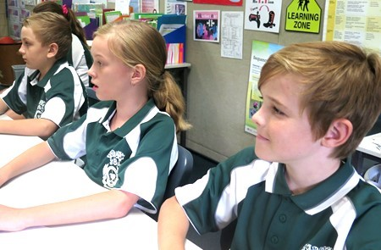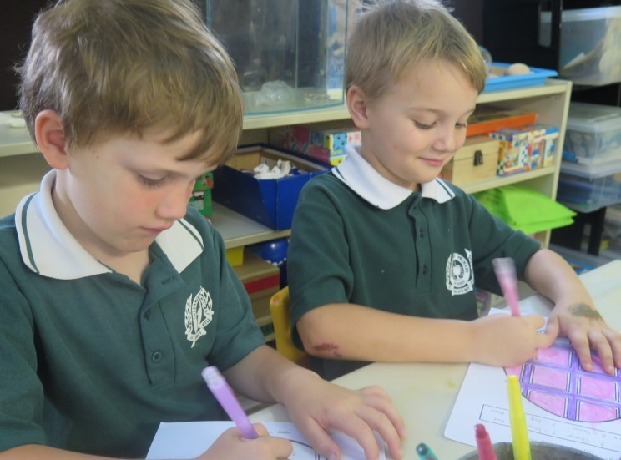

**ENGLISH**

Greenmount Primary School ensures students develop an appreciation for language, focussing

on the development and strengthening of essential literacy skills.

***Targets:***

•

*The Year 3 and 5 average to be equal to or*

*higher than*

Like Schools

*average in*

*NAPLAN Literacy testing*

•

*Increase the percentage of students in*

*higher bands when compared to*

Like

Schools

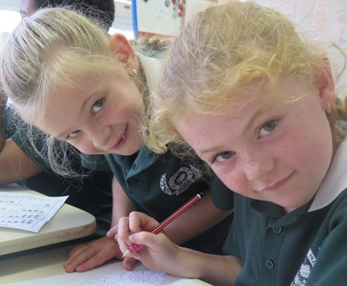

**INTENTIONS**

**SUCCESS CRITERIA**

***Whole school data is used to set***

***targets for improvement and***

***plan effectively at school,***

***class and individual level***

•

Assessment schedule incorporates relevant and diagnostic data

which informs teaching and learning programs

•

Student progress is monitored at team and whole school level

•

Targets set reflect focus on continuing school improvement

•

Network focus on Writing in 2018 is built on to develop best

practice in all classrooms

***Opportunities are provided to***

***challenge and extend students***

***’***

***learning***

•

Collaborative and integrated tasks are included in classroom

Literacy programs

•

Students in higher bands are identified and extended with age

appropriate activities

•

Parent group is trained to provide additional support for

Phonological Awareness and Reading programs throughout the

school

***Content and key skills are***

***explicitly taught and students are***

***provided with quality feedback***

***on progress***

•

Continue to implement the West Australian curriculum,

*First Steps*

literacy strategies and DoE and SCSA resources

•

Team planning identifies key skills to be taught each term using

*On Entry*

data, NAPLAN data and performance profiles

•

Learning Intentions and Success Criteria are clearly articulated for

students and feedback informs students of their progress.

•

Feedback is targeted, timely and specific

•

Assessments provide information about student progress and

impact of teaching

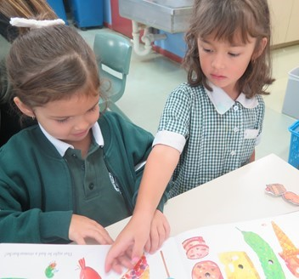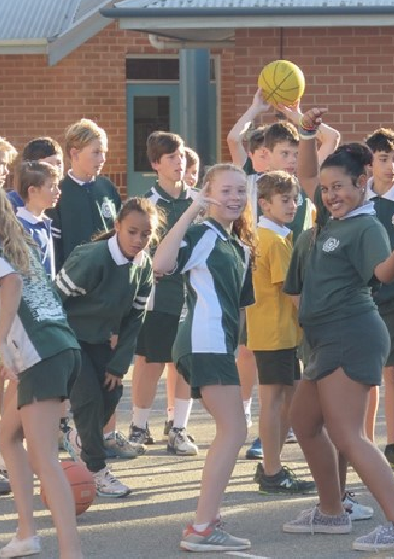

**Our School Song**

***Settled in the bushland high above the city***

***A lone pine stands on Blackboy Hill planted in our history***

***Soldiers trained upon the ground where we now work and play***

***Their bravery and valour we aspire to today***

***Our emblem is our badge of honour worn with pride***

***At Greenmount Primary we are learning side by side***

***We respect each person***

***’***

***s differences whilst working as a team***

***Through friendship, fun and hard work we can realise our dreams***